# Phase 9: Reporting, Dashboards & Security Review

## **Reports**

**a) Case Resolution Report**

**Purpose:** Track how many days each grievance case took to resolve.

* **Report Type:** Grievance Cases
* **Fields / Columns:**
  + Case Number (Auto Number)
  + Complaint Type
  + Status
  + Created Date
  + Closed Date
  + Formula Field: Days to Resolve = ClosedDate - CreatedDate
* **Filters:**
  + Status = Closed
  + Created Date = Current Month (optional)
* **Grouping:**
  + Group by Complaint Type or Department
* **Chart:**
  + Bar / Column chart showing **average days to resolve.**

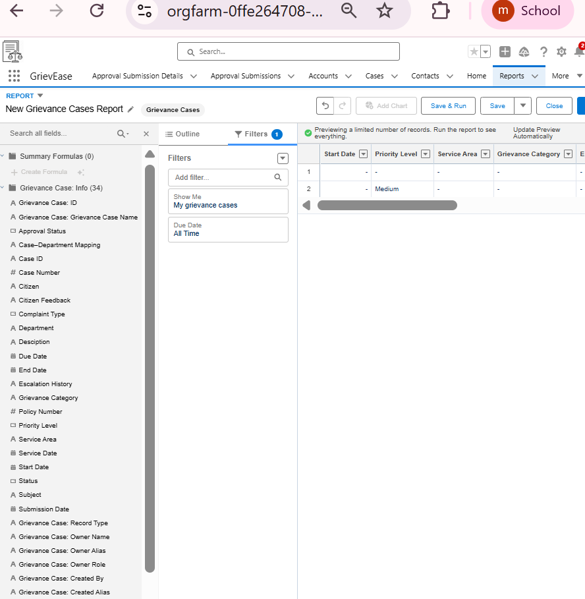

## Report Types

**Step 1 – Go to Report Types**

1. **Setup → Quick Find → Report Types**
2. Click **“New Custom Report Type”**

**Step 2 – Define the Primary Object**

* **Primary Object:** Grievance Case
* **Report Type Label:** GrievEase Cases with Citizens
* **Report Type Name:** GrievEase_Cases_with_Citizens
* **Description:** “Report on Grievance Cases and their associated Citizens”
* **Store in Category:** GrievEase Reports
* **Deployment Status:** **Deployed**
* Click **Next**

## Dashboards

**Create a New Dashboard**

1. **Setup → Dashboards → New Dashboard**
2. **Name:** GrievEase Dashboard
3. **Folder:** Public or GrievEase Reports
4. **View By:** Department, Officer, or default

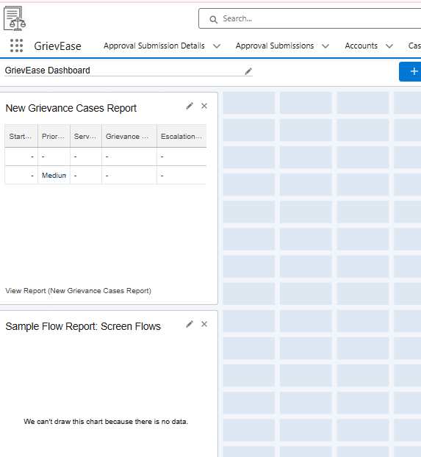

## Dynamic Dashboards

**. Create the Base Dashboard**

1. **Setup → Dashboards → New Dashboard**
2. **Name:** GrievEase Agent Dashboard
3. **Folder:** Public or GrievEase Reports
4. **View By:** Leave as default for now (we’ll make it dynamic later)

**2. Add Components**

* Use **reports that support dynamic filtering** (e.g., Cases by Agent / Assigned To)
* Example components:
  + **Bar chart:** Number of cases by priority
  + **Table:** Open cases assigned to the agent
  + **Metric:** Total cases resolved this month

## Sharing Settings Overview

| **Object** | **Access Level** | | **Purpose** |
| --- | --- | --- | --- |
| Bookings / Grievance Cases | **Private** | | Only the owner (or those above in role hierarchy) can view/edit the record |
| Cars / Citizens | **Public Read/Write** | | Everyone can see case info |
| Field Level Security **1. Go to Field Settings**   1. **Setup → Object Manager → Grievance Case** 2. Click **Fields & Relationships** 3. Select the field: **Customer_ID_Proof__c**   **2. Set Field-Level Security**   1. Click **Set Field-Level Security** 2. You’ll see a list of profiles (e.g., Agent, Manager, System Admin) 3. Uncheck **Visible** for the **Agent profile** 4. Leave **Visible** checked for **Manager / Admin** 5. Click **Save** | |

## Session Settings

Step 1 – Go to Session Settings

Setup → Quick Find → Session Settings

Click Session Settings

Step 2 – Configure Session Timeout

Find “Timeout Value for User Sessions”

Set it to 30 minutes

## 

## Login IP Ranges

**Step 1 – Identify the Profile**

1. Go to **Setup → Profiles**
2. Select the **Agent / Support Profile** (the one assigned to your field agents)

**Step 2 – Set Login IP Ranges**

1. Scroll down to **Login IP Ranges**
2. Click **New**
3. Enter the **Start IP Address** and **End IP Address**

## Audit Trail

**Setup → Object Manager → Grievance Case → Fields & Relationships**

Click **Set History Tracking**

Check fields you want to track, e.g.:

* Priority__c
* Status__c
* Assigned_To__c

Click **Save**